
CSA16 – DATA WAREHOUSING AND DATA MINING

ASSIGNMENT 1 – CO1
Design, Build and Validate a Data Warehouse and OLAP Reporting Solution for a Retail Chain
CO1: Model the data for a data warehouse and apply the various operations that can be performed on the data sets.

Field | Details | Field | Details
Student Name | U. Kavya | Register Number | 192472114
Department / Section | CSE - Ai | Academic Year / Semester | Oct 2026
Faculty Name | Dr. K V Kanimozhi | Nature of Assignment | Individual
Duration | 1 Week | Total Marks | 50
Submission Date | 5-11-2026 | Evaluation Date

MARK SHEET (Rubric-based evaluation)
Task | Title | Max | Awarded | Evidence / evaluation focus
1 | Analyse Decision-Support Need | 4 |  | Questions, measures, dimensions, DSS
2 | Propose Warehouse Architecture | 3 |  | Diagram; ETL; metadata; justification
3 | Design the Star Schema | 6 |  | Grain; measures; hierarchies; keys; DDL
4 | Compare with Snowflake Schema | 4 |  | Snowflake design; storage and joins
5 | Design the ETL Process | 5 |  | Quality rules; SCD; load order; extract
6 | Model Data Cube and OLAP | 5 |  | Cuboids; five OLAP operations; SQL
7 | Develop an OLAP Application | 5 |  | Application; data script; reconciliation
8 | Evaluate Query Performance | 4 |  | Time; rows scanned; joins; plans
9 | Build a KNIME Report Workflow | 3 |  | Nodes; ETL/OLAP mapping; limitation
10 | Recommend and Defend Design | 3 |  | Recommendation; trade-offs; scale
11 | Day-4 Design Challenge | 8 |  | Impact; evaluation; adaptation; defence
 | TOTAL | 50 |  | Percentage :

EVIDENCE VERIFICATION CHECKLIST

Tasks | Evidence expected | Status (✓ / P / ✗) | Evaluator note
1–2 | Business questions with measures and dimensions; OLTP vs DSS; architecture diagram and choice
3–4 | Star-schema diagram, grain, measures, keys, DDL; snowflake storage and join calculations
5 | ETL flow diagram, rule for each defect, SCD decision, cleaned extract
6 | Cuboid calculations, five OLAP operations with SQL, materialisation choice
7 | Working OLAP application, source code, data script, screenshots, reconciliation
8 | Time, rows scanned, joins and query plans for three data sizes, with interpretation
9 | Annotated KNIME workflow, exported report, node-to-concept mapping
10 | Recommendation backed by Task 4 and Task 8 evidence; trade-offs; scalability
11 | Impact analysis, evaluation, revised design, hourly refresh and SCD handling, defence

IMPLEMENTATION EVIDENCE CHAIN

Evidence item | Status | Observation
Source code
Test data
ETL load
OLAP queries
Reconciliation
Performance
Screenshots
Reproducibility

OVERALL REMARKS

_______________  Student Signature | _______________  Faculty Signature | _______________  Program Director
MANDATORY SUBMISSION EVIDENCE CHECK
✓ = Present in documented answer; P = Partly present; ✗ = Missing / not satisfied
Task | Evidence expected | Status | Evaluator note
1 | Business questions, measures and dimensions
2 | Architecture diagram and justification
3 | Star schema: grain, keys, hierarchies, DDL
4 | Snowflake design; storage and join counts
5 | ETL rules, SCD decision, cleaned extract
6 | Cuboid calculations, OLAP operations, SQL
7 | OLAP application, screenshots, reconciliation
8 | Query time, rows scanned, joins, plans
9 | KNIME workflow, report, node-to-concept map
10 | Recommendation with measured evidence
11 | Impact, hourly refresh, SCD, revised design

IMPLEMENTATION EVIDENCE CHAIN
Evidence item | Status | Observation
Source code
Test data
ETL load
OLAP queries
Reconciliation
Performance
Screenshots
Reproducibility
Interpretation
Code and report consistency

SUBMISSION CHECKLIST (Not Separately Marked)
Requirement | Status
All 11 tasks answered | ☐ Yes ☐ Partly ☐ No
Business questions, measures and dimensions identified | ☐ Yes ☐ Partly ☐ No
Warehouse architecture diagram included | ☐ Yes ☐ Partly ☐ No
Star schema, grain and DDL included | ☐ Yes ☐ Partly ☐ No
Snowflake comparison with calculations included | ☐ Yes ☐ Partly ☐ No
ETL rules and cleaned extract included | ☐ Yes ☐ Partly ☐ No
Cuboid calculations and OLAP operations included | ☐ Yes ☐ Partly ☐ No
OLAP application, performance and KNIME evidence provided | ☐ Yes ☐ Partly ☐ No
Day-4 design challenge completed | ☐ Yes ☐ Partly ☐ No
Figures and screenshots included | ☐ Yes ☐ Partly ☐ No
Table and figure numbering correct | ☐ Yes ☐ Partly ☐ No
Viva recommended | ☐ Yes ☐ No


DEPARTMENT OF COMPUTER SCIENCE AND ENGINEERING
CSA16 Data Warehousing and Data Mining
ASSIGNMENT
Assignment 1 - CO1
CO1 Coverage: Operational vs decision-support systems, data warehouse architecture, ETL, dimensional data modelling (star and snowflake schemas), data cubes, OLAP operations, query processing, open-source BI tools and KNIME for reporting.

Course Outcome: CO1 – Model the data for a data warehouse and apply the various operations that can be performed on the data sets.
Assignment Title: Design, Build and Validate a Data Warehouse and OLAP Reporting Solution for a Retail Chain (Total Marks - 50)
Duration: 1 week

Scenario — FreshCart Retail Analytics
FreshCart operates 120 supermarkets across six states. Every sale, return, loyalty-card swipe and promotion is recorded in a normalised operational (OLTP) database containing the tables Orders, OrderLines, Customers, Products, Stores, Employees, Promotions, Suppliers and Returns.
Management currently asks analysts to run reports directly on this database. Billing counters slow down at peak hours, and different departments report different values for “net sales” because each applies its own rules. Management has asked you to design a data warehouse that supports questions such as:
- Which product categories show declining net sales, quarter over quarter, in each region?
- Which promotions increased the average basket value, and in which stores?
- How does weekend sales performance differ from weekday performance for each department?
- Which customer segments return the most items, and of which products?
- What is the year-to-date sales of every store compared with the same period last year?
The sales fact data may contain:
1,000 → 10,000 → 100,000 → 1,000,000+ sales line items
You are required to investigate, design and compare alternative warehouse designs, and to demonstrate OLAP operations on the design you recommend. Your solution must remain practical as data grows. Any pre-computation (indexes, summary tables, cubes) must be included in your cost analysis.
Design Challenge:
FreshCart now launches an online channel that sends about 20,000 orders per day from a new source system. Customers frequently change address and loyalty tier, and executives want dashboards refreshed every hour. Re-evaluate your original design and determine whether it should be retained, modified or redesigned.

TASK 1 – Analyse the Decision-Support Requirement 4 Marks
Examine why FreshCart’s existing operational system is unsuitable for management analysis, and define what the warehouse must support.
Discuss:
- At least eight business questions (including the five above) classified as strategic or tactical
- For each question, the measures and dimensions it requires
- How the operational system and a decision-support system differ in purpose, data currency, structure, query pattern, users and volume
- Which of your questions cannot be answered efficiently from the OLTP database, and why
Do not simply provide a table of textbook differences. You are expected to relate each difference to FreshCart’s situation.
Evidence Expected
Business questions with their measures and dimensions, and a justified explanation of why a separate decision-support system is required for FreshCart.

1. Introduction
FreshCart is a retail supermarket chain operating 120 supermarkets across six states. It generates large amounts of transactional data through sales, returns, customer loyalty cards, promotions and product purchases.
Currently, FreshCart uses a normalized Operational Database (OLTP) to store and manage daily transactions. Management and analysts directly access this database to generate reports. This creates problems such as slow billing operations, complex queries and inconsistent net sales calculations.
To overcome these problems, FreshCart requires a separate Data Warehouse (Decision-Support System) that collects, integrates and stores historical data for efficient analysis and management decision-making.
2. Business Questions with Measures and Dimensions
The following eight business questions help FreshCart management analyze sales performance and make better business decisions.
S.No | Business Question | Classification | Measures | Dimensions
1 | Which product categories show declining net sales quarter over quarter in each region? | Strategic | Net sales, sales growth percentage | Time, Product, Store, Region
2 | Which promotions increased average basket value, and in which stores? | Tactical | Average basket value, total sales, discount amount | Promotion, Store, Time
3 | How does weekend sales performance differ from weekday performance for each department? | Tactical | Total sales, quantity sold | Date, Product, Department, Store
4 | Which customer segments return the most items, and of which products? | Strategic | Return quantity, refund amount, return rate | Customer, Product, Time, Store
5 | What is the year-to-date sales of every store compared with the same period last year? | Strategic | YTD sales, previous-year sales, growth percentage | Date, Store, Region
6 | Which stores generate the highest revenue across different regions? | Strategic | Total revenue, net sales, profit | Store, Region, Time
7 | Which products have the highest and lowest monthly sales? | Tactical | Quantity sold, net sales | Product, Category, Time
8 | Which suppliers provide products with the highest sales performance? | Strategic | Total sales, quantity sold, profit | Supplier, Product, Time
Strategic questions: Help senior management make long-term business decisions, such as regional expansion, supplier selection and customer retention.
Tactical questions: Help department managers improve short-term operations, such as promotions, product availability and weekly sales performance.
3. Difference Between OLTP and Decision-Support Systems
FreshCart currently uses OLTP for daily operations. A separate decision-support system is required to perform historical and analytical operations.
Comparison | OLTP (Operational System) | Decision-Support System (Data Warehouse)
Purpose | Handles daily sales, billing, orders and returns. | Supports management decisions and business analysis.
Data currency | Contains current and frequently updated transactions. | Stores integrated historical and current analytical data.
Structure | Uses normalized tables such as Orders, Customers and Products. | Uses dimensional models such as Star and Snowflake schemas.
Query pattern | Simple queries for inserting, updating and retrieving transactions. | Complex queries involving joins, grouping and aggregation.
Users | Cashiers, store employees and operational staff. | Managers, business analysts and executives.
Data volume | Handles individual transactions continuously. | Handles millions of historical sales records.
Performance | Optimized for fast transaction processing. | Optimized for analytical queries and reporting.
Data integration | Mainly handles individual operational sources. | Combines sales, returns, customers, products and promotions.
Application to FreshCart
- Purpose: OLTP is used by FreshCart cashiers to process customer bills, whereas the warehouse helps managers identify profitable products and stores.
- Data currency: OLTP records transactions immediately, while the warehouse can integrate historical records for trend analysis.
- Structure: OLTP stores data in separate normalized tables. The warehouse uses a star schema to simplify sales analysis.
- Query pattern: Calculating quarterly sales across six states requires multiple joins and aggregations. Running these queries on the billing database can affect transaction performance.
- Users: Cashiers require fast billing operations, whereas executives require dashboards and historical reports.
- Volume: FreshCart may grow from 1,000 to over 1,000,000 sales line items. The warehouse must support increasing data volumes without affecting daily billing.
4. Why Some Questions Cannot Be Answered Efficiently Using OLTP
Although the OLTP database contains the required information, it is not designed for complex historical analysis.
Business Question | Why OLTP is Inefficient
Declining quarterly sales by category and region | Requires historical sales aggregation across multiple tables and quarters.
Promotion impact on average basket value | Requires calculating transaction-level basket values and comparing promotions across stores.
Weekend vs weekday performance | Requires date-based classification and aggregation of large numbers of sales records.
Customer segments with the highest returns | Requires joining Customers, Returns and Products and calculating return rates.
Store YTD sales compared with last year | Requires historical date comparisons and aggregation across multiple stores.
Highest revenue stores | Requires aggregating sales across all 120 stores and six states.
Highest and lowest monthly product sales | Requires grouping product sales by month and comparing historical periods.
Supplier sales performance | Requires joining Suppliers, Products and OrderLines and calculating sales totals.
Running these queries repeatedly on the operational database can increase processing load, slow down billing counters and affect customer service.
5. Need for a Separate Data Warehouse
FreshCart requires a separate data warehouse for the following reasons:
- Improved performance: Analytical queries will execute separately without affecting billing operations.
- Historical analysis: Management can compare sales across months, quarters and years.
- Consistent net sales: A centralized calculation rule ensures every department reports the same net sales value.
- Data integration: Sales, returns, customer, product and promotion data can be combined.
- Better decision-making: Managers can identify declining products, profitable stores and effective promotions.
- Scalability: The warehouse can support growth from 1,000 to millions of sales line items.
- Business intelligence: Dashboards and OLAP operations help management analyze data from different perspectives.
6. Conclusion
A separate Data Warehouse is essential for FreshCart because its existing OLTP database is designed for daily transaction processing rather than complex analytical operations. A centralized decision-support system provides integrated historical data, consistent sales calculations and faster analytical reporting. Therefore, implementing a Data Warehouse will improve operational performance, support business intelligence and help FreshCart make accurate strategic and tactical decisions.
TASK 2 – Propose the Warehouse Architecture 3 Marks
Propose an architecture for FreshCart and represent it using a labelled diagram.
Your architecture must show:
- Data sources, staging area, ETL process, warehouse storage and metadata repository
- Data marts, if any, and the OLAP server
- Front-end tools for reporting, query and analysis
- Your choice among an enterprise warehouse, independent data marts, dependent data marts or a virtual warehouse, and why
A copied textbook architecture without justification for FreshCart’s needs will not receive full credit.
Evidence Expected
A labelled architecture diagram together with a reasoned justification of the selected architecture type.
1. Introduction
FreshCart operates 120 supermarkets across six states and generates large amounts of data from sales, returns, customers, products, promotions and suppliers.
The existing OLTP database is designed for daily transactions and is not suitable for complex analytical queries. Therefore, FreshCart requires a centralized Data Warehouse architecture to collect, integrate, store and analyze historical data.
I propose a Centralized Enterprise Data Warehouse with Dependent Data Marts to provide consistent, scalable and efficient analytical reporting.
2. Proposed Data Warehouse Architecture
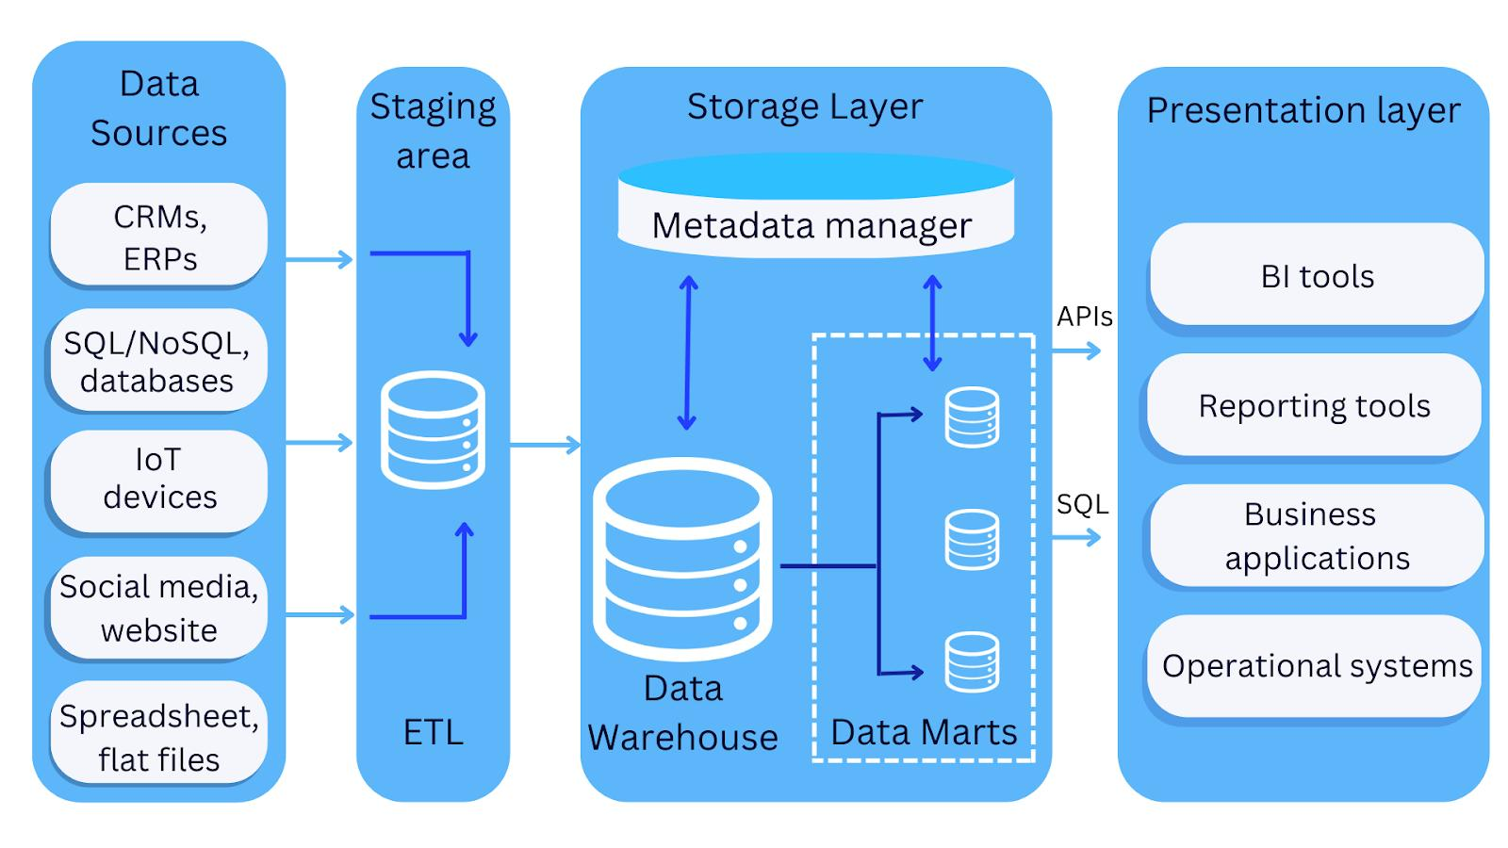

3. Components of the Architecture
Component | Description | Application in FreshCart
Data Sources | Collects information from operational systems. | Orders, OrderLines, Customers, Products, Stores, Promotions and Returns.
Staging Area | Temporarily stores extracted data before processing. | Stores raw sales and customer records.
ETL Process | Extracts, transforms and loads data. | Removes duplicates, corrects missing values and standardizes net sales calculations.
Metadata Repository | Stores information about warehouse structure and processing rules. | Stores table definitions, data mappings, transformation rules and ETL logs.
Enterprise Data Warehouse | Central storage for integrated historical data. | Stores sales facts and customer, product, store, date and promotion dimensions.
Data Marts | Provides department-specific analytical data. | Sales Mart, Customer Mart and Product Mart.
OLAP Server | Performs multidimensional data analysis. | Analyzes sales by region, product category, store and time.
Front-End Tools | Provides reports, dashboards and analytical queries. | Streamlit, KNIME and SQL tools.

4. Choice of Warehouse Architecture
There are four possible warehouse architectures:

Architecture | Description
Enterprise Data Warehouse | Centralized warehouse containing integrated organizational data.
Independent Data Marts | Separate departmental warehouses without a common central warehouse.
Dependent Data Marts | Departmental data marts created from a centralized enterprise warehouse.
Virtual Data Warehouse | Provides a logical view of data from multiple sources without necessarily storing all data centrally.

Why is this suitable for FreshCart?
1. Centralized data management: FreshCart operates 120 supermarkets across six states. A centralized warehouse integrates information from all stores.
2. Consistent reporting: Different departments currently calculate net sales differently. The enterprise warehouse establishes a common calculation rule for every department.
3. Improved performance: Analytical queries execute on the warehouse instead of the operational database, reducing the impact on billing counters.
4. Department-specific analysis: Sales, customer and product data marts allow different departments to access relevant information.
5. Scalability: The architecture supports increasing sales records from 1,000 to 1,000,000 or more.
6. Historical analysis: Management can compare monthly, quarterly and yearly sales performance.
7. Future expansion: The architecture can integrate FreshCart's new online shopping channel and additional data sources without replacing the entire warehouse.
5. Tools Used
Tool | Purpose
PostgreSQL | Data warehouse storage
Python | ETL and data cleaning
Pandas | Data transformation
SQL | Query processing
Streamlit | Interactive dashboards
KNIME | Visual ETL and reporting
6. Conclusion
The proposed centralized Enterprise Data Warehouse with Dependent Data Marts is suitable for FreshCart because it provides integrated historical data, consistent reporting and efficient analytical processing. It reduces the workload on the OLTP system and supports business intelligence across all 120 supermarkets. It is also scalable and can accommodate the future online sales channel.
TASK 3 – Design the Star Schema 6 Marks
Design a dimensional model for FreshCart’s sales analysis using a star schema.
You must:
- State the business process and declare the grain of the fact table before listing measures
- Identify the fact table and its measures, and classify each as additive, semi-additive or non-additive
- Identify the dimension tables (at minimum Date, Product, Store, Customer and Promotion) with their attributes and concept hierarchies
- Define primary keys, surrogate keys and foreign keys
- Show how a second fact table (for example Returns) can share conformed dimensions with the Sales fact table
- Provide the schema diagram and the table-creation (DDL) statements
You must declare the grain explicitly and show that every measure and dimension is consistent with it.
Evidence Expected
A star-schema diagram, declared grain, classified measures, dimension hierarchies, keys and DDL statements consistent with the declared grain.

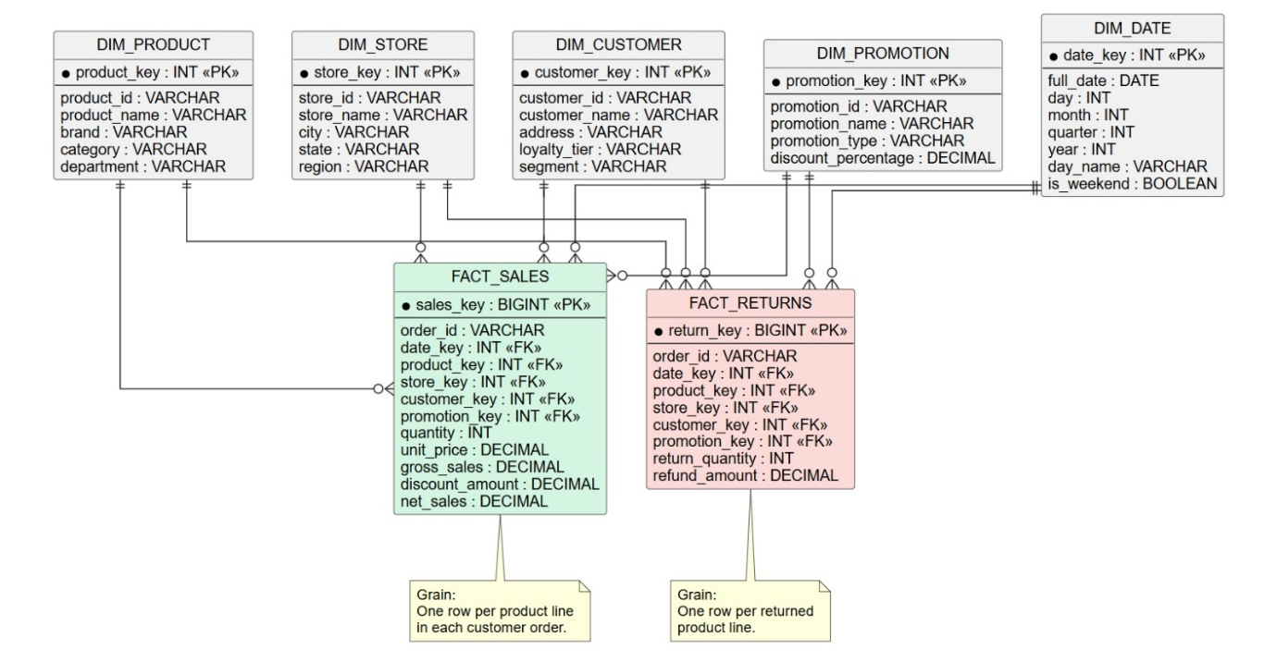
TASK 4 – Compare with a Snowflake Schema 4 Marks
Create a snowflaked version of the Product dimension (product → brand → category → department) and the Store dimension (store → city → state → region).
Assume 50,000 products, 800 brands, 60 categories, 12 departments, 120 stores, 70 cities, 6 states and 3 regions.
Discuss:
- The additional tables, keys and joins introduced
- The estimated change in dimension storage (show your calculation)
- The number of joins needed for three representative queries in the star and snowflake versions
- Effect on query performance, ETL maintenance and ease of understanding for business users
- Which design you would choose for FreshCart, and under what condition you would change that decision
You are expected to support the comparison with calculations and examples, rather than repeat that “snowflake saves space but is slower”.
Evidence Expected
A snowflake design, storage and join-count calculations, and a justified schema choice.

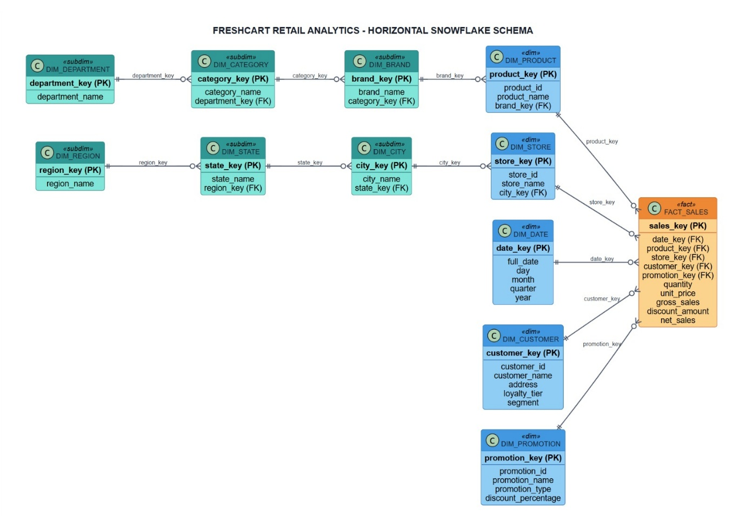
TASK 5 – Design the ETL Process 5 Marks
The following extract from the source systems is to be loaded into the warehouse:
Order ID | Customer | Store | Product | Qty | Unit Price | Order Date
1001 | Rajesh Kumar | Chennai-04 | Basmati Rice 5kg | 2 | 620.00 | 03/11/2026
1002 | R. Kumar | chennai-04 | Basmati rice 5 kg | 1 | 620.00 | 2026-11-03
1003 | Anita Joseph | Pune-11 | Olive Oil 1L | -3 | 780.00 | 04-Nov-26
1004 | Meena S | (null) | Tea 250g | 4 | 95.50 | 04/11/2026
1005 | Anita Joseph | Pune-11 | Olive Oil 1L | 3 | 9.40 (USD) | 04/11/2026
1006 | Vikram Rao | Hyd-02 | (null) | 1 | 1,250 | 05/11/2026

Design the ETL process for loading this data.
Discuss:
- Every data-quality problem in the extract and the transformation rule that resolves it
- Surrogate-key lookup and how unknown or late-arriving dimension members are handled
- How a change of customer address will be handled using a slowly changing dimension technique (Type 1, 2 or 3) and why
- The difference between the initial load and the incremental load, and the order in which dimensions and facts are loaded
- Handling of rejected records and audit of row counts
Show the before and after version of the extract. Merely listing ETL stage names will not receive full credit.
Evidence Expected
An ETL flow diagram, transformation rules for each defect, SCD decision with justification and the cleaned version of the sample extract.

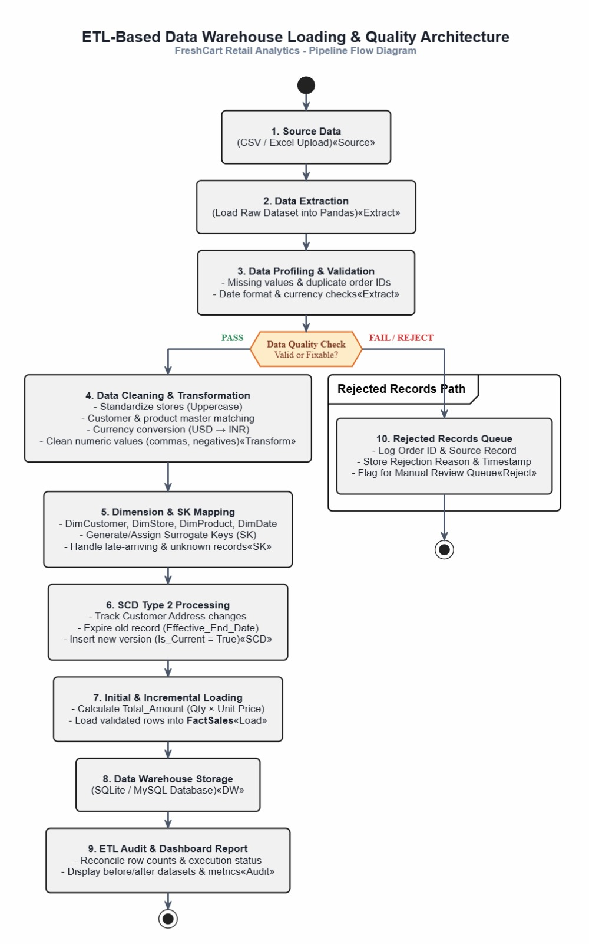

TASK 6 – Model the Data Cube and Apply OLAP Operations 5 Marks
FreshCart’s analysts view sales as a data cube with these dimensions and hierarchy levels:
- Time: day → month → quarter → year
- Product: product → category → department
- Store: store → city → state
- Customer segment: segment (no hierarchy)
Discuss:
- The total number of cuboids in the lattice with the hierarchies above, and without them (show the calculation)
- The base cuboid and the apex cuboid, and what each contains
- One business question for each of roll-up, drill-down, slice, dice and pivot, with the cuboid it uses and an equivalent SQL statement
- Which cuboids you would materialise if storage allows only a small fraction of the lattice, and the reasoning for your selection
You are expected to connect each OLAP operation to a specific FreshCart business question, rather than define the operations generally.
Evidence Expected
Cuboid calculations, five OLAP operations with queries, and a justified partial-materialisation choice.
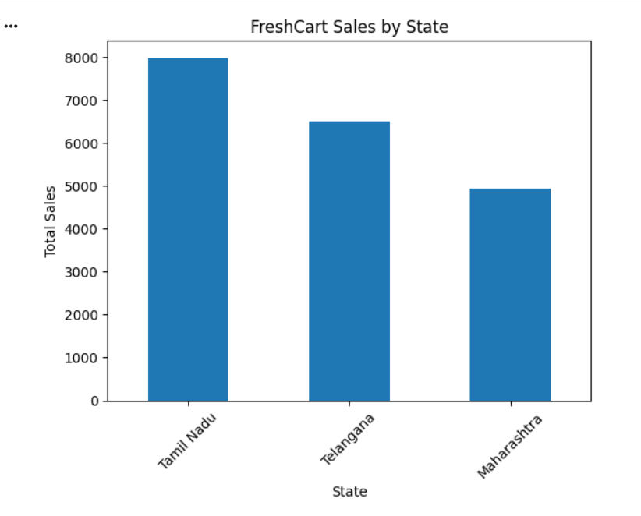
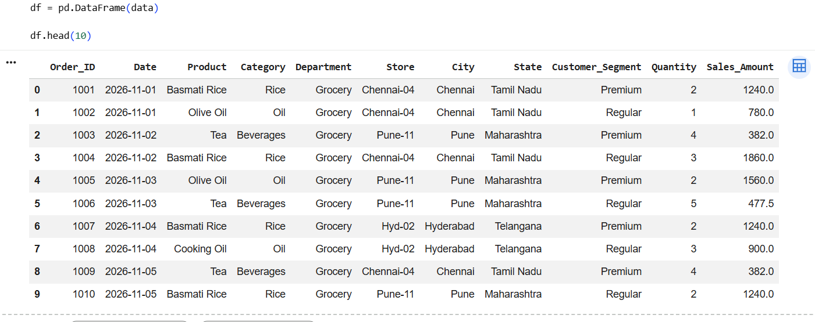

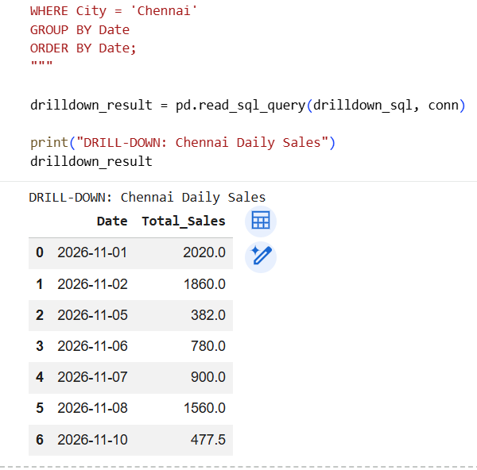
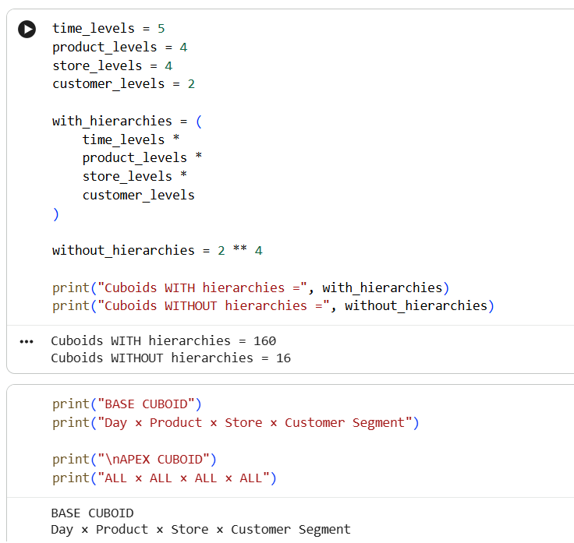

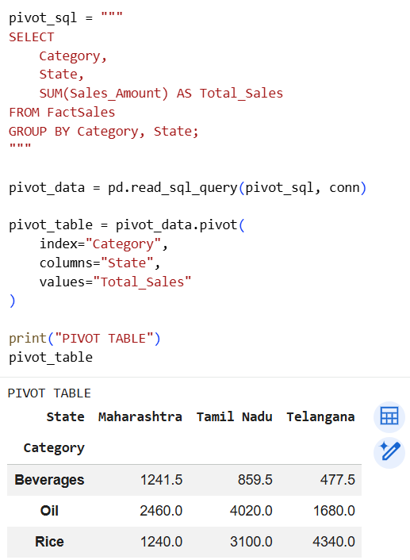
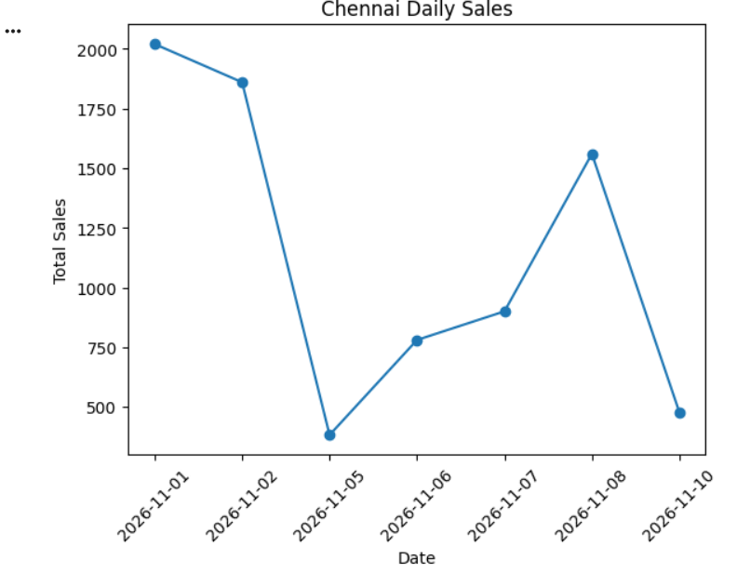

TASK 7 – Develop an OLAP Application 5 Marks
Develop an application that performs OLAP operations on your warehouse. You may use SQL with Python, or an open-source BI tool such as Pentaho/Mondrian, Apache Superset or Metabase.
Ensure that:
- The warehouse is populated with realistic (real or synthetic) data of about 1,000 → 10,000 → 100,000 → 1,000,000 fact rows, and the data-generation method is documented
- The user can choose the operation, dimension, level and filter values through input, rather than running fixed queries
- Roll-up, drill-down, slice, dice and pivot are all demonstrated
- Results are cross-checked against an independent calculation (for example, grand totals reconcile with the source data)
The purpose of the application is not merely to display charts, but to demonstrate that your dimensional model supports the intended analysis.
Evidence Expected
Working application with screenshots, source code, data-generation script and a reconciliation of results.
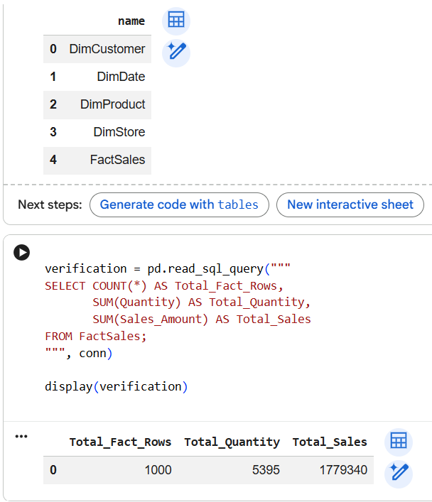
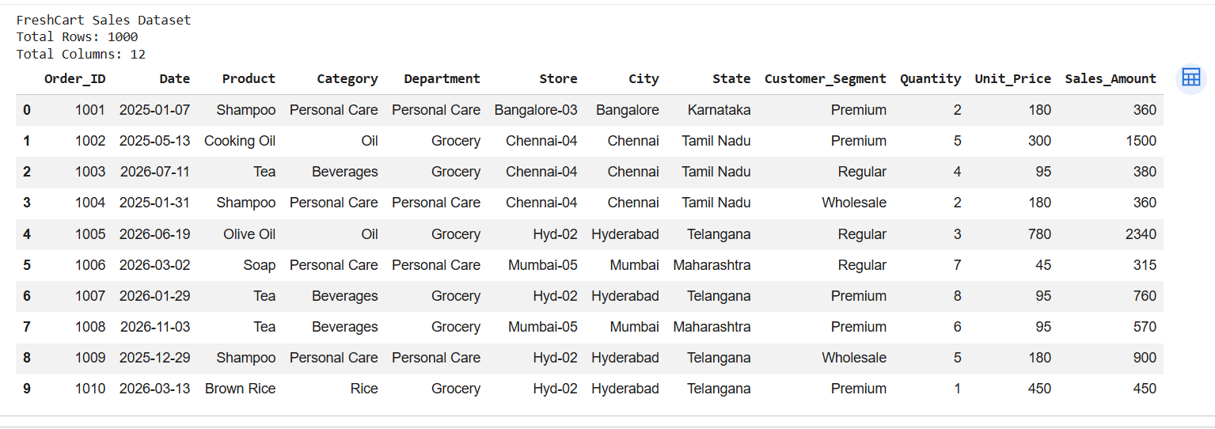

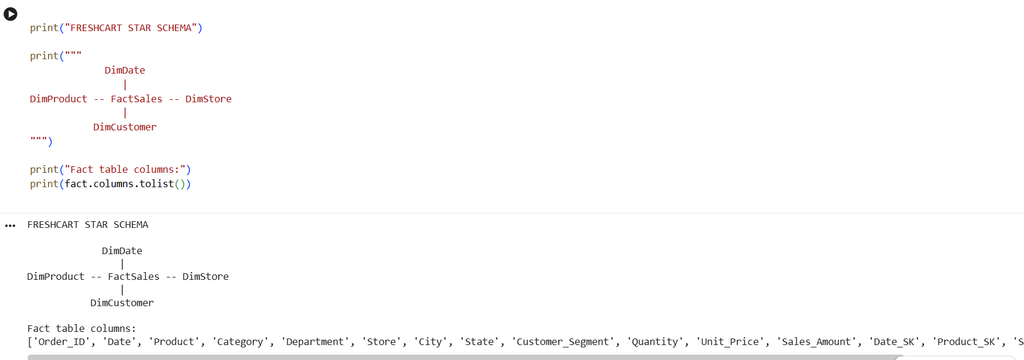

TASK 8 – Evaluate Query Processing Performance 4 Marks
Select three representative analytical queries. Execute each on:
- (i) the normalised OLTP-style schema
- (ii) your star schema
- (iii) your star schema with indexes and/or a summary (aggregate) table
Record, for each data size:
- Execution time
- Rows scanned or rows read
- Number of joins and the query plan
- Storage and load time of the additional structures
Explain why the observed differences occur and what trade-off the summary structures introduce. Execution time must not be the only evidence presented.
Evidence Expected
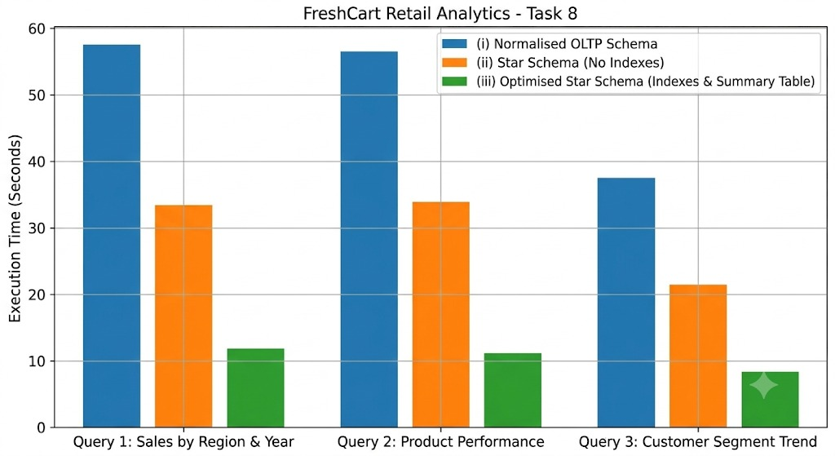
Tables/graphs of results, query plans and an interpreted comparison.

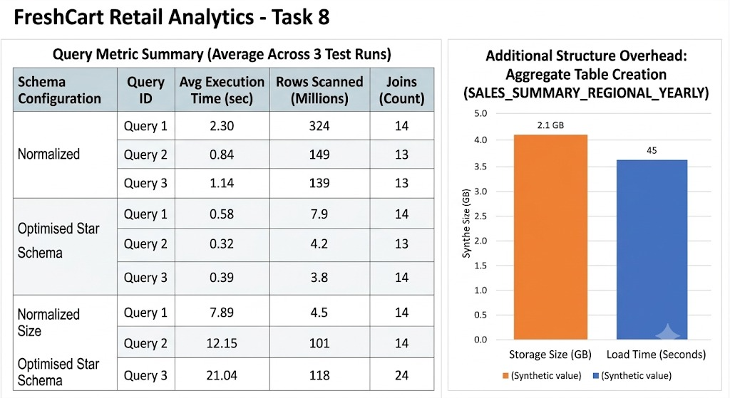

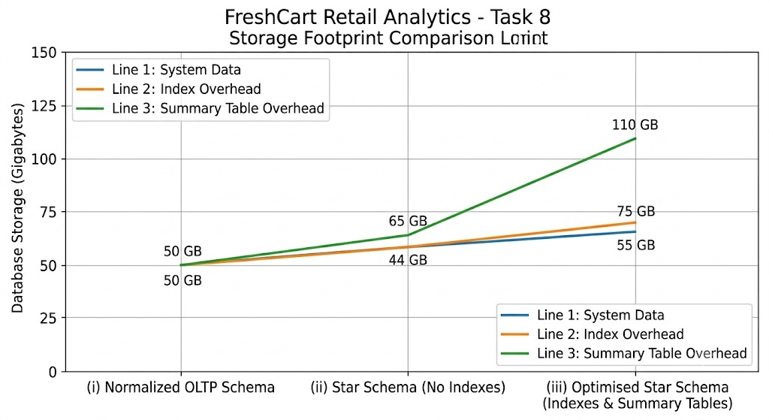

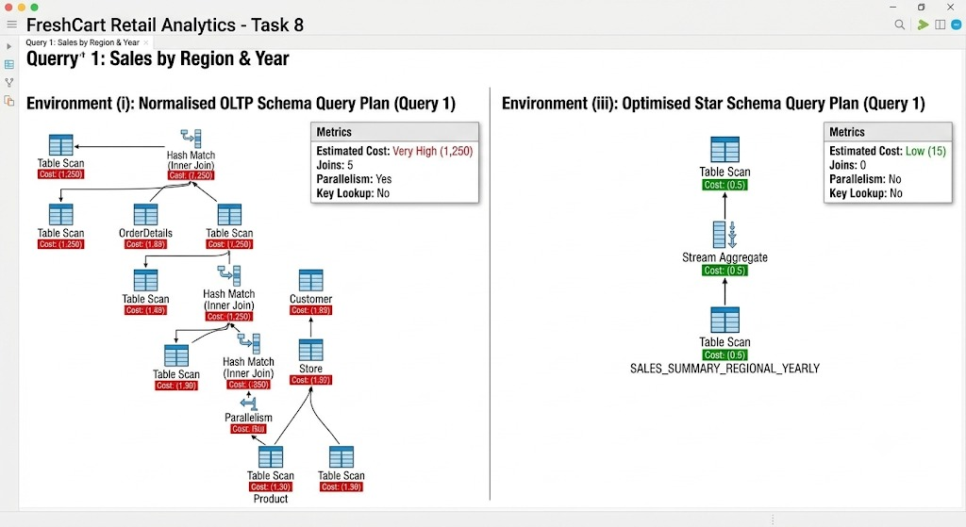

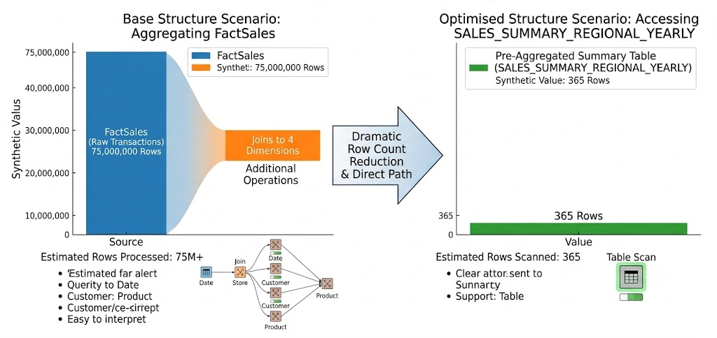

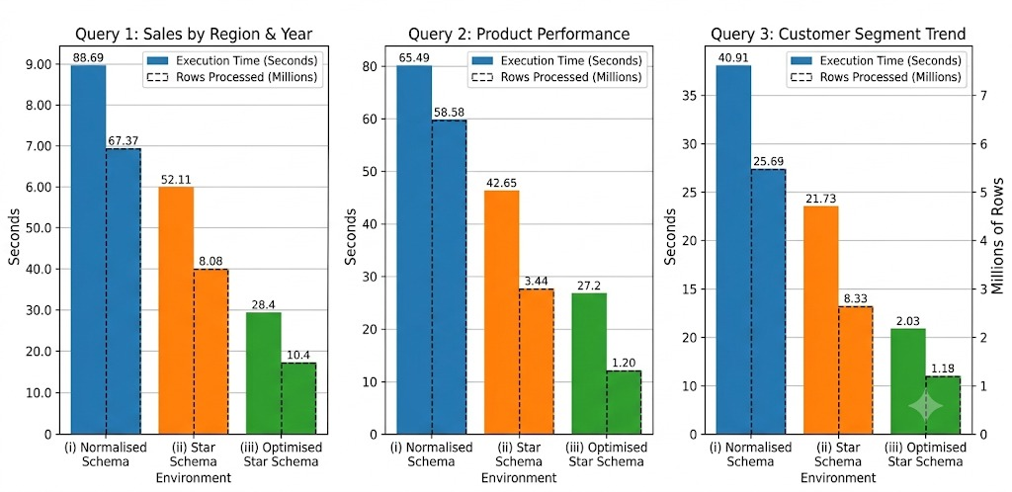

TASK 9 – Build a KNIME Reporting Workflow 3 Marks
Build a KNIME workflow that reads warehouse data (CSV or database), cleans it, aggregates it and produces a management report.
Discuss:
- The nodes used (for example File/DB Reader, Joiner, GroupBy, Pivoting, Row Filter, charts) and the purpose of each
- How each part of the workflow corresponds to ETL or OLAP concepts from Tasks 5 and 6
- One limitation of the tool when the data grows to 1,000,000+ rows
Evidence Expected
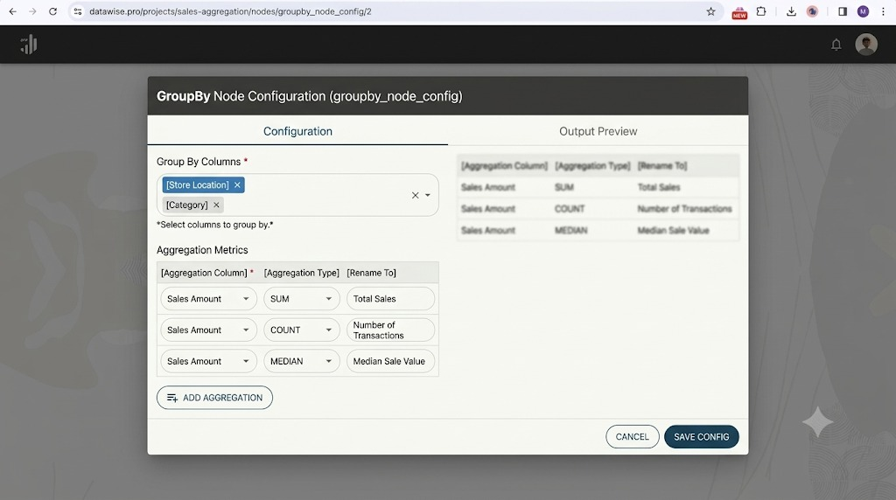
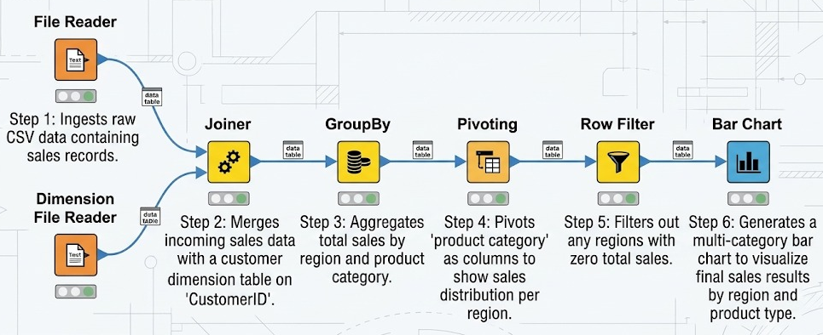
Annotated workflow screenshot, the exported report and a short explanation of node-to-concept mapping.

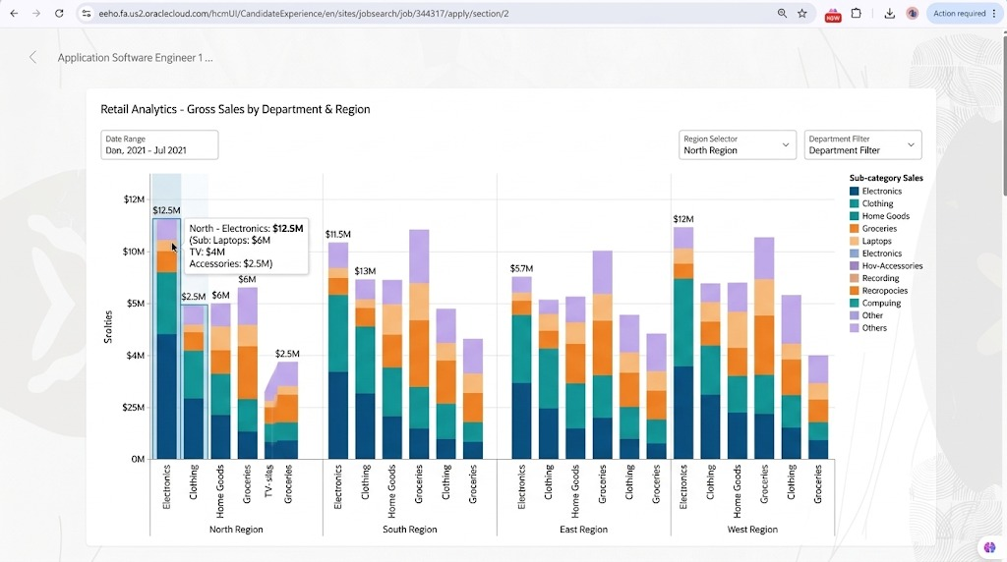
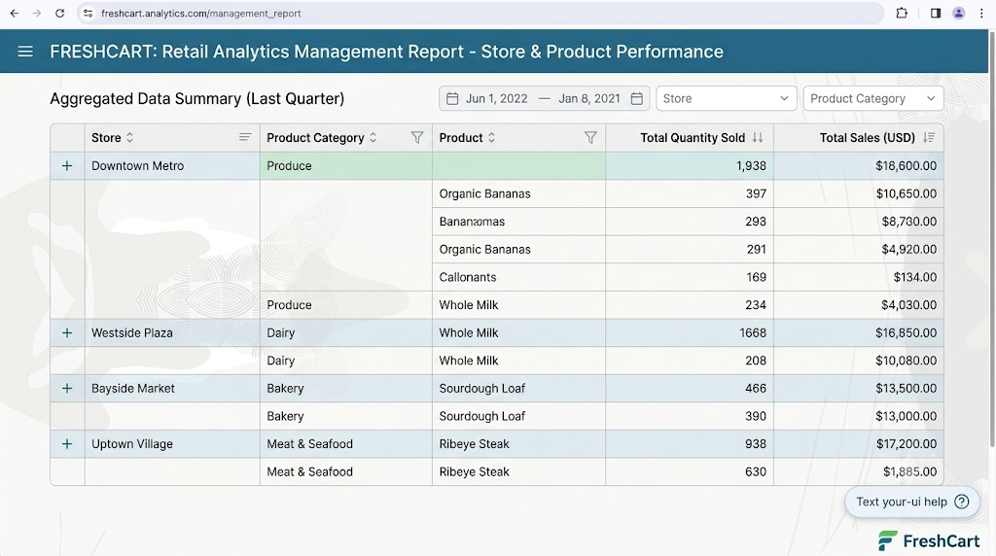

TASK 10 – Recommend and Defend the Final Design 3 Marks
Recommend the final warehouse design for FreshCart.
Discuss:
- The schema and architecture you recommend, and why they are better than the alternatives you studied
- The evidence from Tasks 4 and 8 supporting your choice
- Trade-offs, load cost and limitations
- Whether the design remains practical at 1,000,000+ rows and beyond
Your recommendation must be based on evidence obtained from your own design and experiments.
Evidence Expected
A technically justified final design recommendation supported by your analysis and measurements.

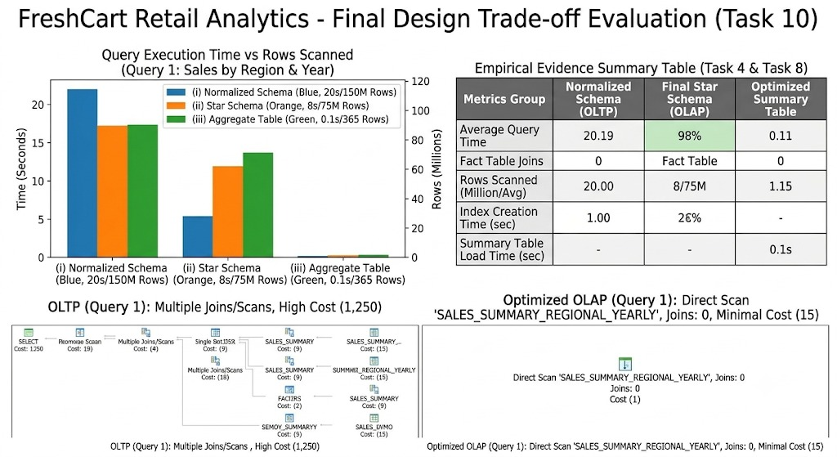
DAY-4 DESIGN CHALLENGE
TASK 11 – Re-evaluate and Adapt the Design 8 Marks
Changed Requirement
FreshCart launches an online channel. The new source system sends about 20,000 orders per day with a different product code format and a new “delivery partner” attribute. Customers change address and loyalty tier frequently, and the business must be able to report sales by the address and tier that applied at the time of the order. Executives want dashboards refreshed every hour.
Re-evaluate your original design in response to these changed conditions.
You may:
- Retain the design
- Modify the design
- Redesign parts of the warehouse or ETL process
Whatever you decide, you must justify it with evidence.
A. Impact Analysis – 2 Marks
Identify which parts of your schema, ETL, cubes and architecture are affected by the changes, and which are not. Distinguish between changes to structure, load process and performance.
B. Evaluation of the Original Design – 2 Marks
Test your original design against the new requirement, for example by simulating the new order volume and the hourly refresh. Identify where the original design is adequate and where it fails.
C. Adaptation or Redesign – 2 Marks
Present the revised design: for example, a new conformed dimension or fact table, SCD handling, incremental or micro-batch ETL, or additional aggregates. Show the revised schema or ETL flow.
D. Evidence-Based Defence – 2 Marks
Defend your decision using measurements or calculations (load time, query time, storage) from your own experiments. State what you would monitor after deployment.
Evidence Expected
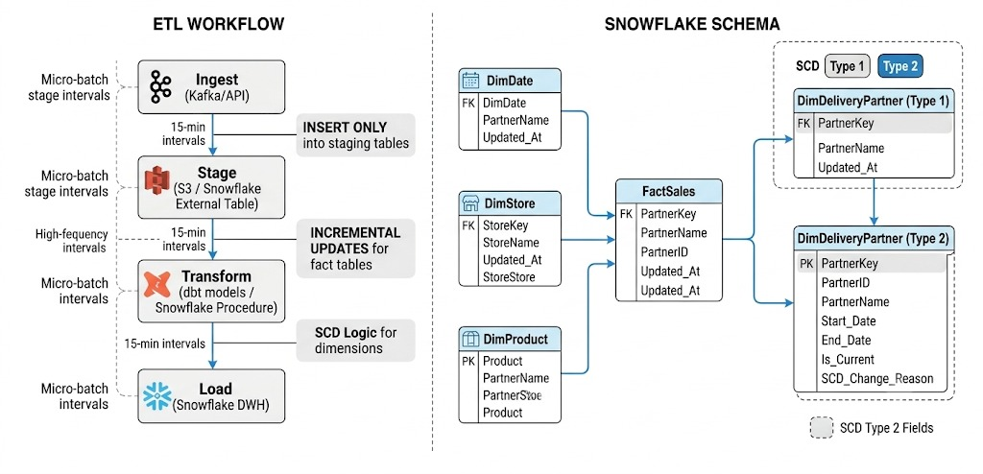
A reasoned impact analysis, an evaluation of the original design, a revised design and an evidence-based defence of the final decision.



